

wearher analysis

Capstone project



Atul kumar dubey

atuldubey09453@gmail.com

**OVERVIEW**

**Weather analysis encompasses a comprehensive examination of key meteorological variables. This includes an overview of the dataset's temporal and geographical dimensions, identifying trends in temperature, humidity, and other attributes over time. The analysis delves into regional variations, pinpointing seasonal patterns and correlations between weather factors. Detection of extreme events and anomalies is crucial, as is the exploration of wind patterns and their potential impact on air quality. Furthermore, the report explores the relationship between temperature and energy consumption in cities.**

**THE PROCESS**

**Data Acquisition from GitHub:** Retrieve and integrate weather dataset from GitHub, ensuring comprehensive data coverage and accuracy.

**Data Transformation and Enhancement:** Perform data cleaning, handle missing values, and enhance dataset quality through transformations, ensuring reliable and consistent data.

**Connecting with Tools:** Utilize relevant tools for data connection and integration, fostering seamless collaboration and efficient analysis.

**Problem Statement Solution in Power BI:** Address specific weather-related problem statements using Power BI, leveraging its capabilities for insightful and actionable solutions.

**Exploratory Data Analysis (EDA):** Conduct a thorough EDA to uncover patterns, trends, and correlations within the weather dataset, providing a holistic understanding of meteorological dynamics.

**Creation of Visual and Insightful PowerPoint:** Generate visually engaging PowerPoint presentations with insightful visualizations, making complex weather data accessible and understandable.

**Detailed Documentation :** Document the entire analysis process, methodologies, and findings, ensuring a comprehensive and transparent record for future reference and collaboration.

**Objective**

Weather analysis aims to comprehensively explore and understand patterns, trends, and key factors influencing meteorological conditions. This project's objective is to conduct an in-depth analysis of weather data, addressing variations across datasets, identifying influential factors affecting weather patterns, uncovering historical trends, and assessing the impact of limitations and biases on weather analysis.

The specific tasks include:

**Comprehensive Analysis:**

Investigate variations in weather datasets, considering different sources and systems.

Identify key factors influencing weather patterns, such as temperature, humidity, wind speed, and more.

**Historical Trend Exploration**:

Analyze historical weather data to uncover trends, patterns, and recurring phenomena.

Explore how specific weather conditions evolve over time and their potential impact on regions.

**Assessment of Limitations and Biases:**

Evaluate potential limitations and biases in the weather data, considering factors like data collection methods, instrumentation, and geographical coverage.

**Insights and Recommendations**:

Derive meaningful conclusions and recommendations based on the analysis results.

Provide insights for better understanding and predicting weather conditions.

**Compilation for Stakeholders:**

Compile analysis results, conclusions, and recommendations in a format accessible to stakeholders, facilitating informed decision-making.

**The success of the project will be measured by:**

**Analysis Quality:** The rigor and accuracy of the weather data analysis.

**Relevance of Insights**: The significance and applicability of the derived insights.

**Impact of Recommendations:** The potential for recommendations to improve weather forecasting and understanding.

This weather analysis project is crucial as it contributes to enhancing our understanding of meteorological patterns, supporting better-informed decision-making in various sectors impacted by weather conditions.

**Significance**

**Significance of Weather Analysis**

Weather analysis holds paramount significance in understanding and navigating the complexities of meteorological conditions, offering far-reaching benefits across various sectors. Let's explore the significance of weather analysis in more detail.

**Informed Decision-Making:** For individuals and communities, weather analysis is vital for making informed decisions related to daily activities, agriculture, and disaster preparedness. By comprehending weather patterns, people can plan their routines, optimize agricultural practices, and take precautions during extreme weather events.

**Economic Impact:** Industries such as agriculture, energy, transportation, and tourism are highly influenced by weather conditions. Accurate weather analysis helps these sectors anticipate and mitigate potential risks, contributing to economic stability and resilience. Farmers can optimize crop planting schedules, energy providers can plan for demand fluctuations, and tourism operators can prepare for weather-related challenges.

**Disaster Management:** Weather analysis plays a crucial role in disaster management. Timely and accurate weather forecasts enable authorities to prepare for and respond to natural disasters such as hurricanes, floods, and wildfires. Evacuation plans, resource allocation, and emergency services coordination rely on weather predictions to minimize the impact of disasters on communities.

**Environmental Conservation:** Understanding weather patterns is essential for environmental conservation efforts. Climate scientists and conservationists leverage weather analysis to monitor changes in climate, track biodiversity, and develop strategies for mitigating the impact of climate change. This information is critical for preserving ecosystems and protecting endangered species.

**Scientific Research:** Meteorological research relies on weather analysis to advance scientific understanding of climate systems, atmospheric phenomena, and the Earth's overall climate. This knowledge contributes to ongoing efforts to address global challenges, such as climate change, by providing insights into long-term trends and potential future scenarios.

**Infrastructure Planning:** Urban planners and engineers use weather analysis to design resilient infrastructure. From constructing buildings that can withstand extreme weather events to planning drainage systems based on precipitation patterns, weather data is instrumental in creating sustainable and climate-resilient cities.

**Public Safety:** Weather analysis directly impacts public safety. Early warnings for severe weather events, such as storms or heatwaves, allow authorities to communicate effectively with the public, reducing the risk of injuries and fatalities. Timely information empowers individuals to take appropriate measures to safeguard themselves and their communities.

**Global Collaboration:** Weather analysis fosters international collaboration in addressing global challenges. Sharing meteorological data and insights enables countries to collaborate on climate research, disaster response, and environmental conservation. This collaboration is essential for developing a comprehensive understanding of worldwide weather patterns and trends.

In conclusion, weather analysis holds profound significance by empowering individuals, industries, and policymakers with the insights needed to make informed decisions, mitigate risks, and contribute to global efforts in environmental conservation and disaster resilience. Embracing the insights gained from weather analysis enables stakeholders to work collaboratively towards creating a safer, more sustainable, and resilient world.

**Data Dictionary**

**Table: City Attributes**

*- Fields:*

country id: Unique identifier for each country.

City id : Unique identifier for each City

**Table: City lookup**

*- Fields:*

city id: Unique identifier for each city.

city name: Name of the city.

**Table: Country**

*- Fields:*

country id: Unique identifier for each country.

country name: Name of the country.

**Table: date lookup**

*- Fields:*

date id: Unique identifier for each date.

Date: Given date for each

**Table: Final fact**

*- Fields:*

Humidity: Contains hourly data representing the humidity levels in each city.

Pressure: Provides hourly data about the air pressure levels in each city.

Temperature: Contains hourly temperature data for each city.

Weather Description:  Provides a textual description of the weather for each city on an hourly basis.

Wind direction: Contains data about the direction from which the wind is blowing on an hourly basis for each city.

Wind speed: Provides hourly data about the speed of the wind in each city

**Table: Time lookup**

*- Fields:*

Time id: Unique identifier for each time.

Time: Given time for each

The data dictionary provides a comprehensive overview of the tables and their respective fields in the dataset. It outlines the relationships between the tables, allowing for a better understanding of the data structure and facilitating the design and implementation of the Power BI Dashboard.

**ER DIAGRAM**

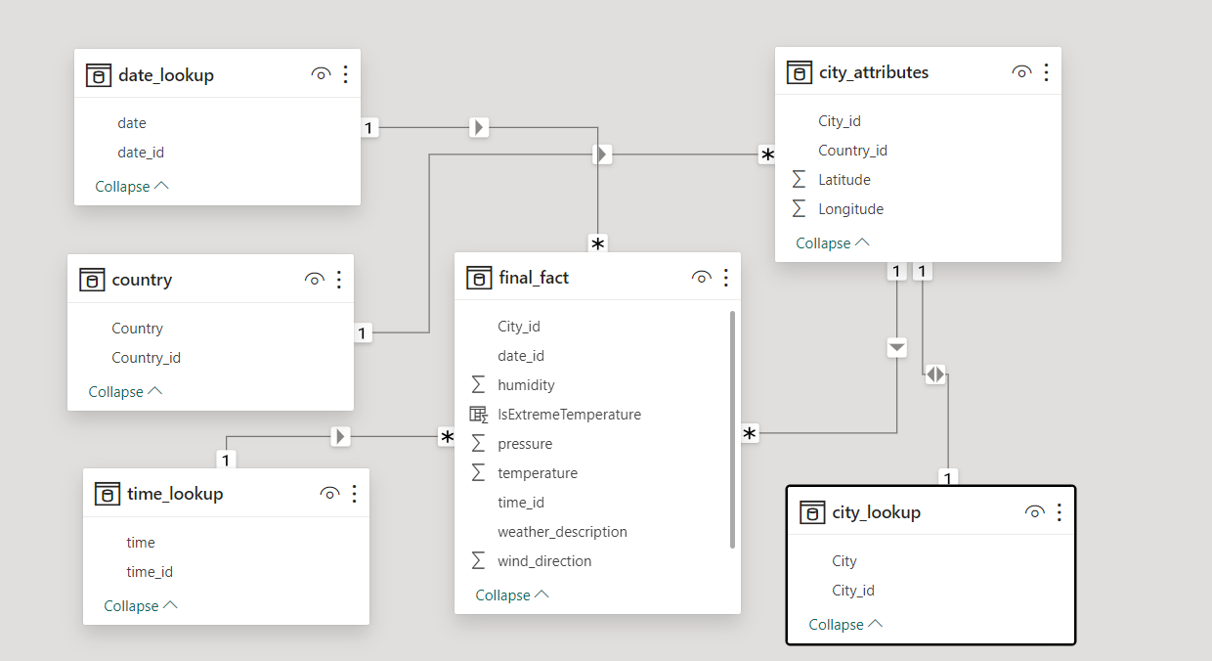

**POWER_BI DASHBOARD**

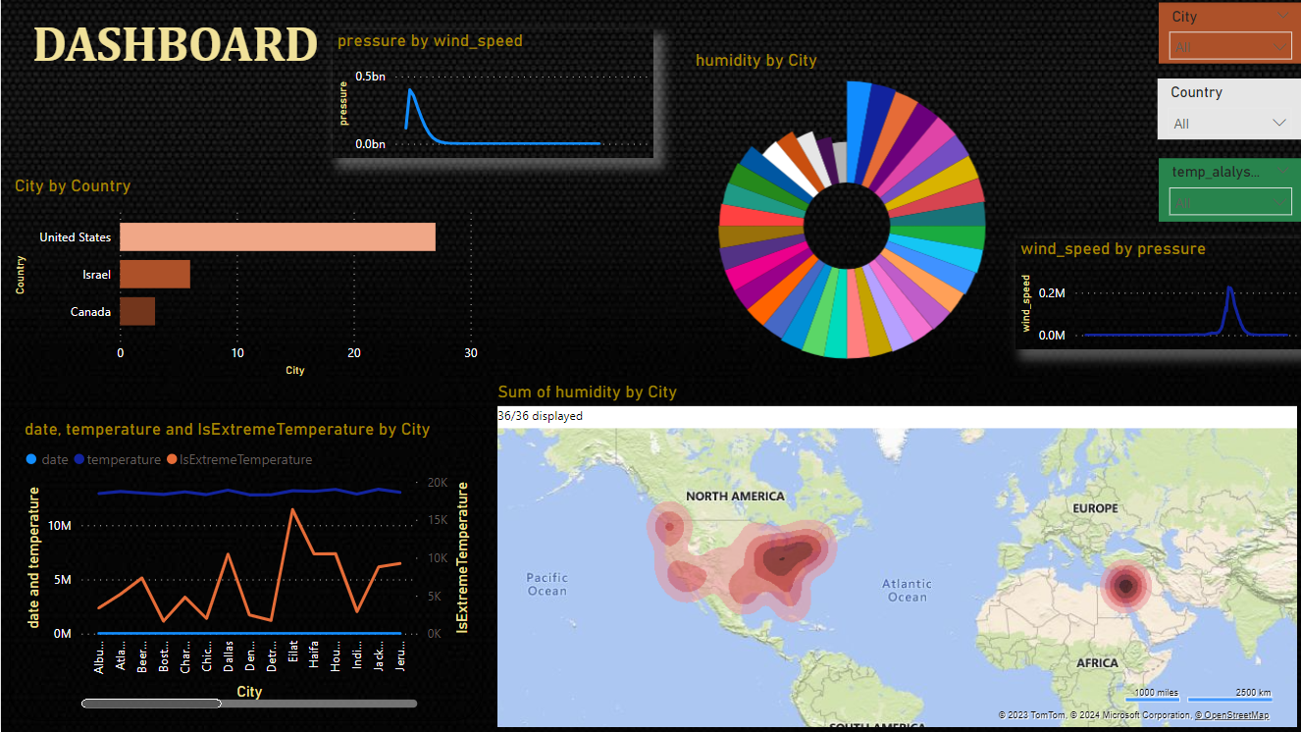

**Geographical map in Power BI showing the distribution of cities in the dataset based on their latitude and longitude**

* **Visual Representation:** The geographical map in Power BI serves as a visual representation of the distribution of cities, offering an intuitive and spatial overview of their locations across the dataset.
* **Latitude and Longitude Coordinates:** The map utilizes latitude and longitude coordinates to accurately position each city on the map, enabling a precise depiction of their geographical locations.
* **Interactivity:** The Power BI map provides interactive features, allowing users to zoom in, zoom out, and hover over specific cities to access additional information. This enhances the user experience and facilitates a deeper exploration of the dataset.

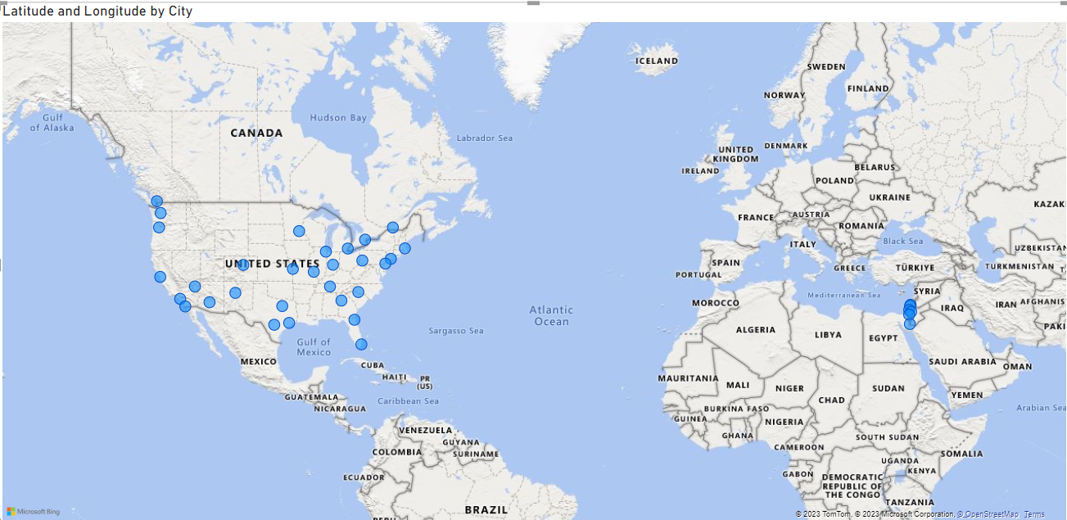

**Bar chart representing the top 10 countries with the highest number of cities in the dataset?**

* **Visual Insight:** The bar chart visually represents the top 10 countries, providing a clear and concise insight into the distribution of cities across different nations in the dataset.
* **Quantitative Comparison:** Through the bar chart, users can easily compare the number of cities in each country, identifying the countries with the highest concentrations of cities. This quantitative analysis aids in recognizing geographical patterns.
* **Data Exploration:** The chart serves as a starting point for further exploration, encouraging users to delve deeper into the dataset to understand the factors influencing the distribution of cities and potential correlations with other variables.

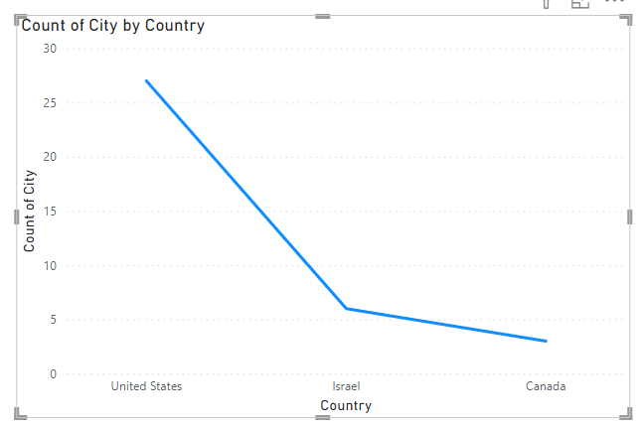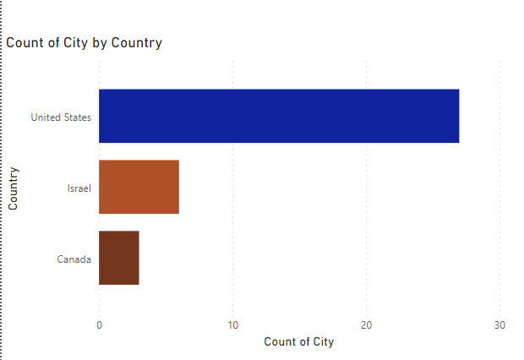

**Distribution of cities in terms of latitude vary across different continents using with scatter plot in Power BI to illustrate this.**

* **Continental Variation:** The scatter plot visually demonstrates how cities are distributed in terms of latitude across different continents. Users can observe whether there are distinct patterns or variations in latitude preferences for cities on different continents**.**
* **Latitude Insights:** The scatter plot allows for the identification of trends or outliers in the latitude distribution. Users can explore whether certain continents exhibit preferences for cities at specific latitudes, providing insights into regional climate or geographical considerations.
* **Interactive Exploration**: The Power BI scatter plot facilitates interactive exploration, enabling users to hover over data points for specific city details. This interactivity enhances the user experience, allowing for a more in-depth understanding of latitude distribution patterns across continents.

**Top of Form**

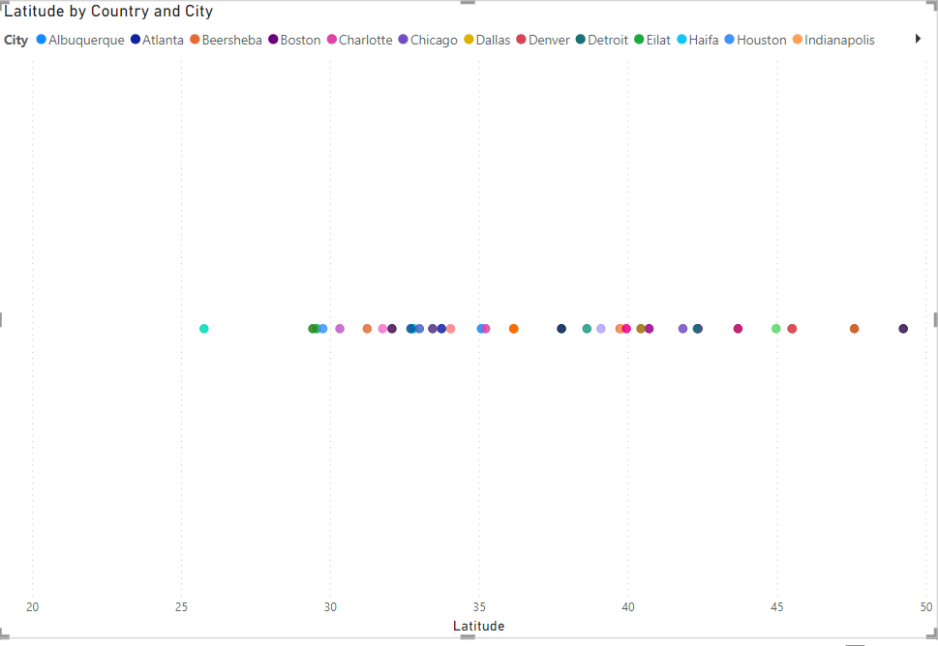

**Create a line chart in Power BI to display the temperature trends over time for a selected city. Highlight extreme temperature events.**

1. **Introduction:**
   * The report focuses on visualizing and analyzing temperature trends over time for selected cities using Power BI.
2. **Data Source:**
   * The dataset comprises temperature data with datetime information for various cities.
3. **City Selection:**
   * Users can dynamically select a city using a slicer or filter, allowing personalized analysis.
4. **Line Chart Visualization:**
   * The main visualization is a line chart displaying temperature trends over time.
   * The X-axis represents datetime, and the Y-axis represents temperature values.
5. **Extreme Temperature Events:**
   * Extreme temperature events are highlighted using conditional formatting.
   * Data points exceeding predefined high and low thresholds are visually emphasized for quick identification.
6. **Trend Line:**
   * A trend line is incorporated to showcase overall temperature trends.
   * This helps users identify patterns such as seasonality or long-term trends.
7. **Tooltip Information:**
   * Tooltips provide detailed information when hovering over data points.
   * Users can view datetime, temperature, and additional relevant details for a comprehensive understanding.
8. **Date Hierarchy:**
   * The date hierarchy feature allows users to drill down into specific time periods (days, months, years) for more detailed analysis.
9. **Annotations:**
   * Annotations are added to mark significant events or periods of interest.
   * This contextualizes temperature trends, such as heatwaves or cold spells.
10. **Dynamic Filtering:**
    * Dynamic filtering options enable users to focus on specific date
11. **Conclusion:**
    * The report provides a comprehensive overview of temperature trends, aiding users in understanding patterns and identifying extreme events.

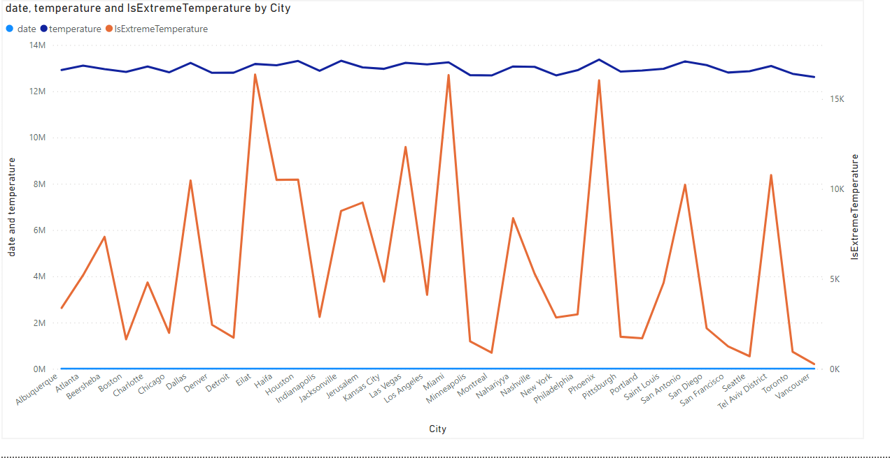

**Humidity vary across different cities which is Generate a heatmap in Power BI to visualize this variation.**

* **Humidity Distribution Overview**: The Power BI heatmap provides an at-a-glance overview of how humidity levels vary across different cities. Users can quickly identify regions or clusters with high or low humidity concentrations, helping to uncover patterns in the data.
* **Geographical Patterns**: The heatmap allows users to discern geographical patterns in humidity distribution. Cities in proximity may exhibit similar humidity levels, providing insights into regional climate variations or influences. This geographical context enhances the understanding of humidity patterns.
* **Data Drill-Down Capability**: The interactive nature of Power BI allows users to drill down into specific areas of the heatmap for detailed information on individual cities. This capability supports a more granular analysis, helping users to explore the factors contributing to humidity variations in particular regions.

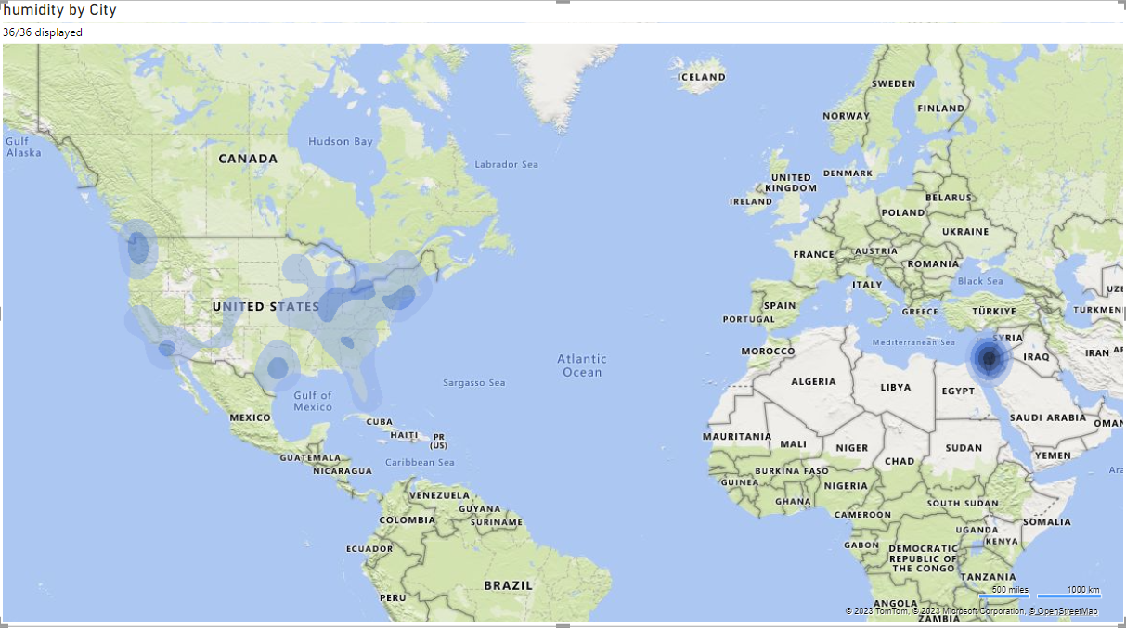

**Time-series chart in Power BI showing the relationship between wind speed and air pressure for a specific city?**

* **Temporal Relationship Visualization:** The time-series chart in Power BI visually represents the dynamic relationship between wind speed and air pressure over time for the selected city. Users can observe trends, fluctuations, and potential correlations between these two weather attributes.
* **Identifying Patterns and Anomalies:** The chart helps users identify patterns or anomalies in the relationship between wind speed and air pressure. Sudden spikes or dips in either variable may indicate specific weather events, and users can leverage the chart to recognize and analyze these occurrences**.**
* **Interactive Analysis:** Power BI's interactive features enable users to zoom in on specific time periods, facilitating a more detailed examination of the wind speed and air pressure dynamics. This interactivity enhances the ability to pinpoint key events and understand the nuances of the relationship between these weather metrics.

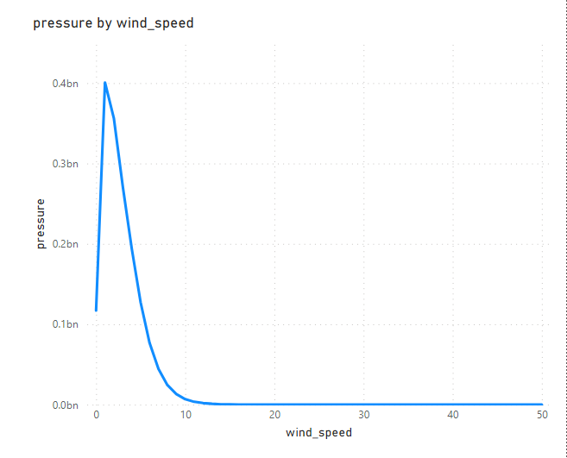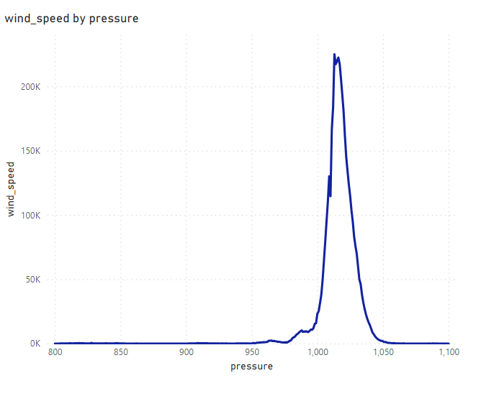

**Time-series line chart in Power BI to show the overall temperature trends over the entire dataset.**

* **Comprehensive Overview:** The time-series line chart in Power BI provides a comprehensive overview of temperature trends across the entire dataset. Users can quickly grasp the general patterns and variations in temperature over time, gaining insights into long-term climate behavior.
* **Seasonal Analysis:** The chart allows for a detailed examination of seasonal fluctuations in temperature. Users can identify recurring patterns, such as temperature spikes during certain months or consistent trends associated with specific seasons, aiding in the understanding of the dataset's temporal dynamics.
* **Highlighting Extreme Events:** Users can leverage the line chart to highlight extreme temperature events, such as heatwaves or cold spells. This visual representation makes it easier to identify outliers or unusual temperature patterns, prompting further investigation into the factors contributing to these extremes.

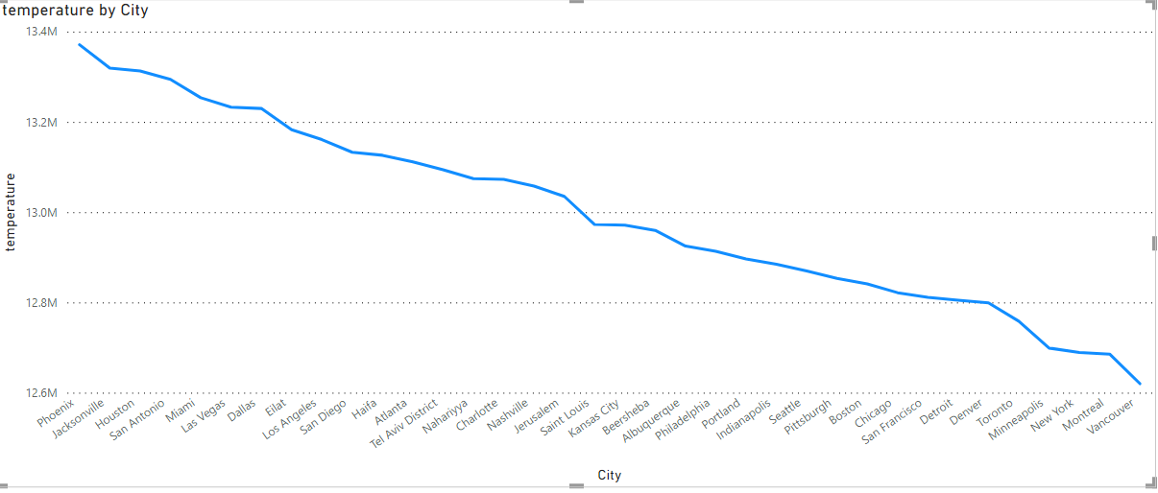

**Heatmap in Power BI to visualize the busiest hours for specific weather conditions (e.g., "clear sky," "rainy")?**

* **Hourly Patterns**: The heatmap in Power BI provides a clear visual representation of the busiest hours for specific weather conditions, allowing users to discern hourly patterns. This is particularly useful for understanding when certain weather conditions, such as "clear sky" or "rainy," are most prevalent throughout the day.
* **Peak Activity Identification:** The heatmap enables users to identify peak activity hours for different weather conditions. This information is valuable for various applications, such as optimizing resource allocation during specific weather events or planning activities that are sensitive to certain weather conditions.
* **Facilitates Decision-Making**: By visually presenting the busiest hours for specific weather conditions, the heatmap assists users in making informed decisions based on temporal weather patterns. This could be crucial for sectors like transportation, event planning, or resource management, where timing is a key factor in decision-making.

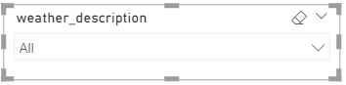

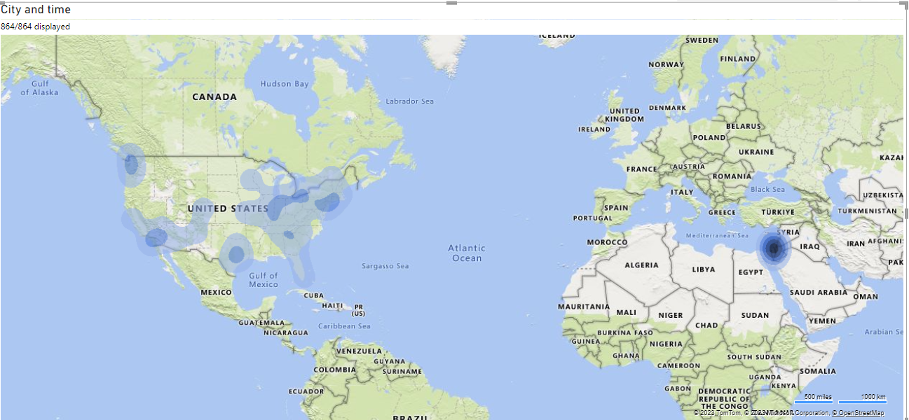

**The wind speed change over the course of a day? Create a radial chart in Power BI to represent this.**

* **Hourly Wind Speed Variation:** The radial chart in Power BI vividly illustrates how wind speed changes over the course of a day, providing an immediate visual understanding of hourly variations. Each concentric circle or segment corresponds to a specific time, allowing for a comprehensive overview.
* **Peak Wind Speed Identification:** Users can easily identify peak wind speeds and their corresponding times by examining the outermost portions of the radial chart. This aids in recognizing the periods of the day when the wind is strongest, which can be crucial for activities sensitive to wind conditions, such as outdoor events or certain industrial operations.
* **Cyclic Patterns and Trends:** The radial representation facilitates the recognition of cyclic patterns or trends in wind speed, helping users discern if there are consistent patterns across different days or if there are irregularities. Understanding these patterns is valuable for making predictions or adjustments based on historical wind behavior.

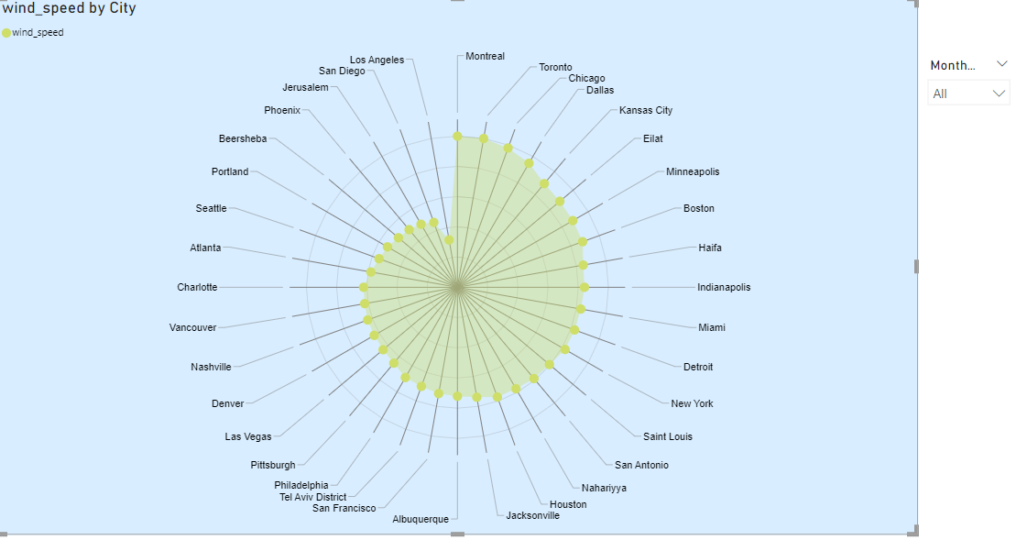

**Power BI chart comparing the temperature variations between two selected cities over a specific timeframe.**

**City-to-City Temperature Comparison:** The Power BI chart provides a clear visual comparison of temperature variations between two selected cities, allowing users to assess how temperatures differ over the specified timeframe. This is valuable for understanding climate disparities and making location-specific observations.

**Identifying Temperature Peaks and Lows:** Users can easily identify peaks and lows in temperature for each city, helping them pinpoint specific times or seasons when one city experiences higher or lower temperatures compared to the other. This information can be essential for various applications, such as travel planning or regional climate analysis.

**Seasonal Trends and Correlations**: The chart enables the observation of seasonal trends and potential correlations in temperature fluctuations between the two cities. This information is valuable for understanding the climatic nuances of each location and identifying if there are consistent patterns or if temperature changes are influenced by external factors.

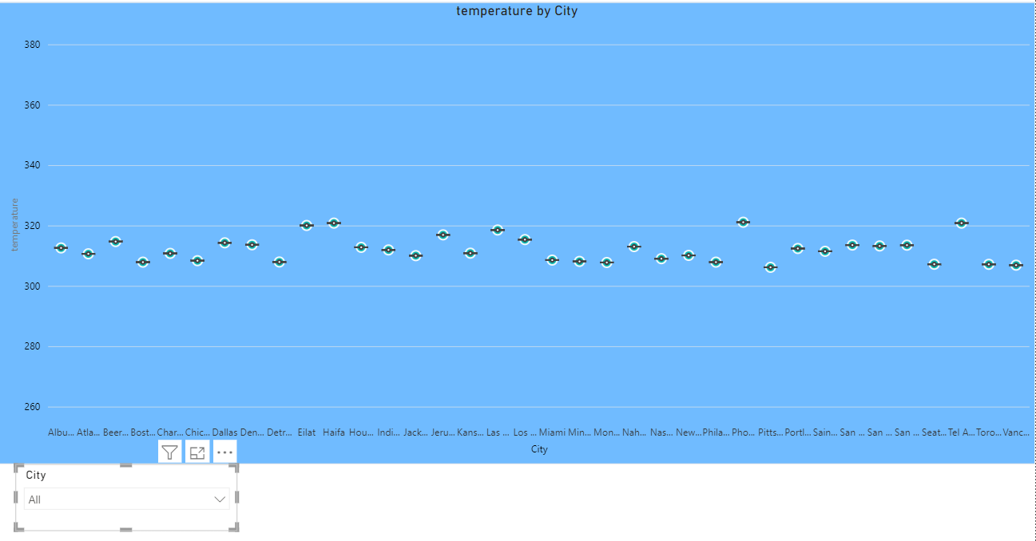

**Build a heatmap in Power BI to show the temperature ranges for cities across different countries?**

* **Geographical Temperature Overview:** The Power BI heatmap provides a comprehensive overview of temperature ranges across different countries and their respective cities. Users can quickly grasp the distribution of temperatures, identifying regions with higher or lower temperature variations**.**
* **Color-Encoded Temperature Intensity:** The heatmap utilizes a color-coded scale to represent temperature intensity, allowing for easy identification of hotspots and cooler areas. This visual representation aids in identifying temperature patterns and understanding which countries or cities experience more extreme temperature ranges.
* **Facilitating Regional Temperature Analysis:** Users can drill down into specific regions or countries, exploring temperature variations within each area. This feature enables more detailed analysis, helping users understand regional climate differences and identify potential factors influencing temperature disparities across the dataset.

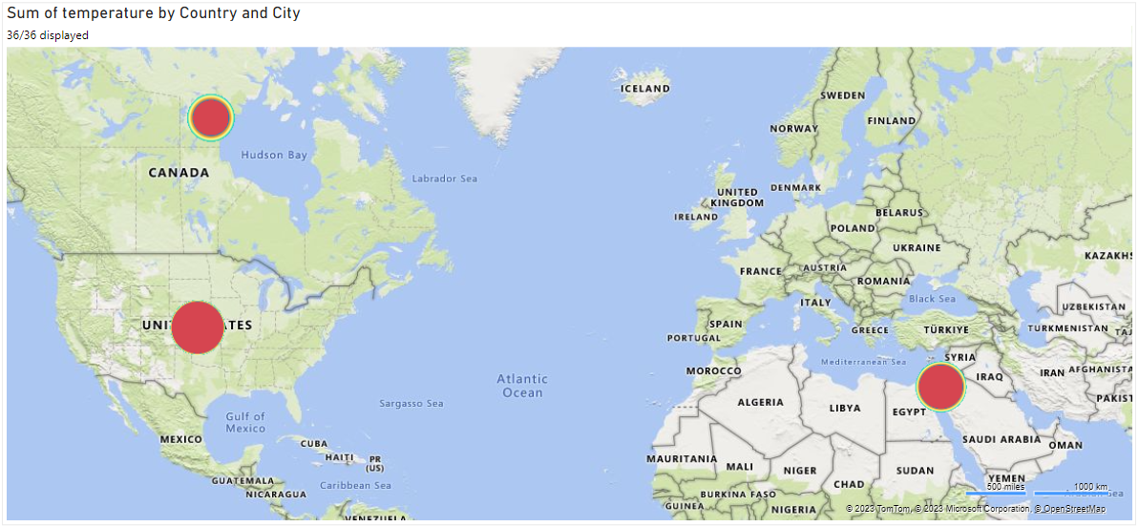

**Bar chart in Power BI to highlight cities with the highest and lowest average temperatures in the dataset**.

* **Clear Temperature Disparities:** The Power BI bar chart visually highlights cities with the highest and lowest average temperatures, providing a clear representation of temperature disparities across the dataset.
* **Identifying Temperature Extremes:** Users can easily identify cities at both ends of the temperature spectrum, helping them recognize areas prone to extreme heat or cold. This information is valuable for various analyses, such as understanding climate patterns or selecting suitable locations for specific activities.
* **Facilitating Comparative Analysis:** The bar chart allows for quick comparisons between cities, enabling users to identify temperature outliers and make informed decisions based on average temperature variations. This feature supports users in selecting cities that align with specific temperature preferences or requirements.

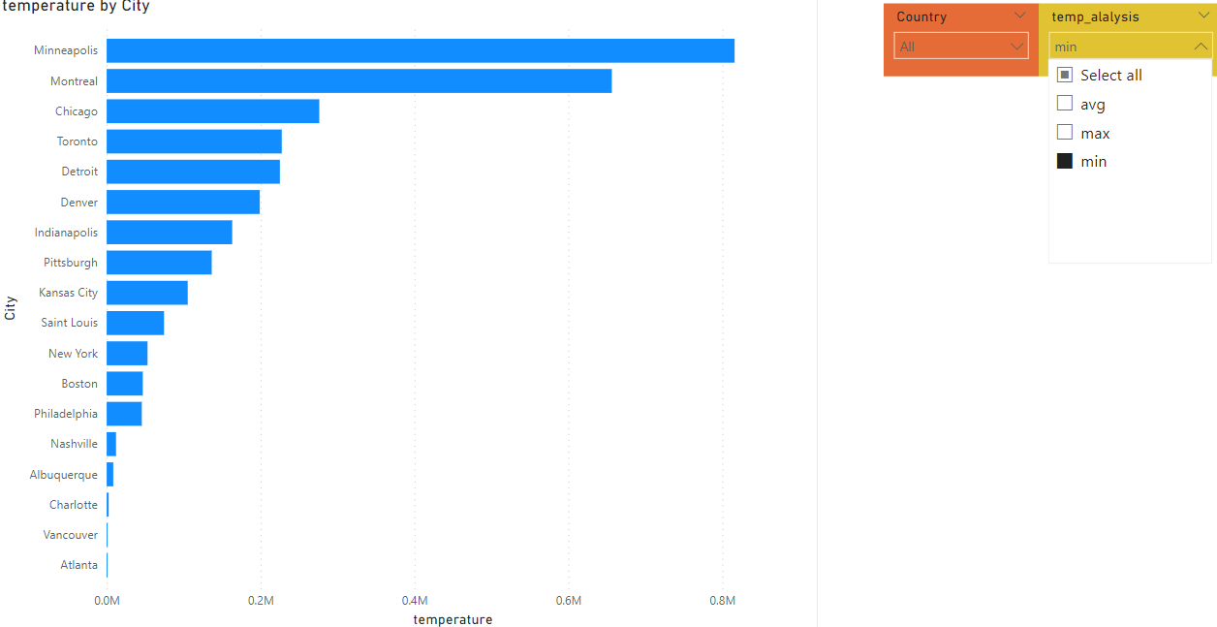

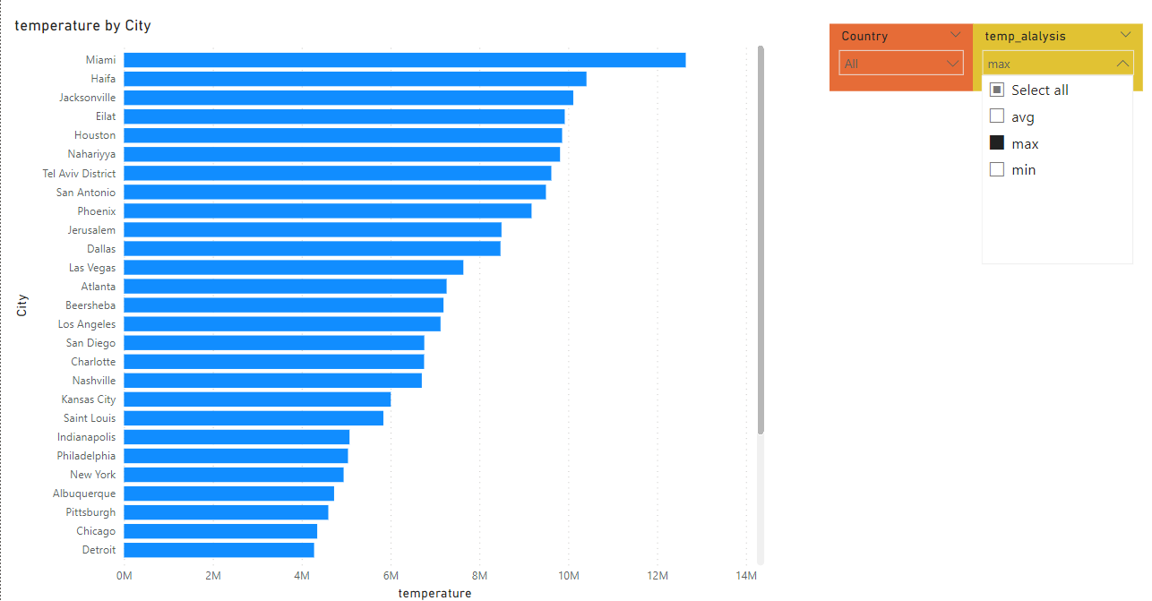

**Wind rose chart in Power BI to visualize the prevailing wind directions for a selected city.**

* **Comprehensive Wind Direction Insight:** The wind rose chart in Power BI offers a comprehensive visualization of prevailing wind directions for a selected city. It provides users with a clear and intuitive representation of the frequency and distribution of winds across different directions.
* **Identifying Dominant Wind Patterns:** Users can easily identify the dominant wind patterns by observing the sectors with higher concentrations in the wind rose. This information is valuable for understanding local climate characteristics and potential influences on various activities, such as urban planning or renewable energy projects.
* **Enhanced Decision-Making:** The wind rose chart facilitates enhanced decision-making by offering a visual summary of the predominant wind directions. This can be crucial for sectors like agriculture, where knowledge of prevailing winds is essential, or for assessing the suitability of locations for wind-based energy projects.

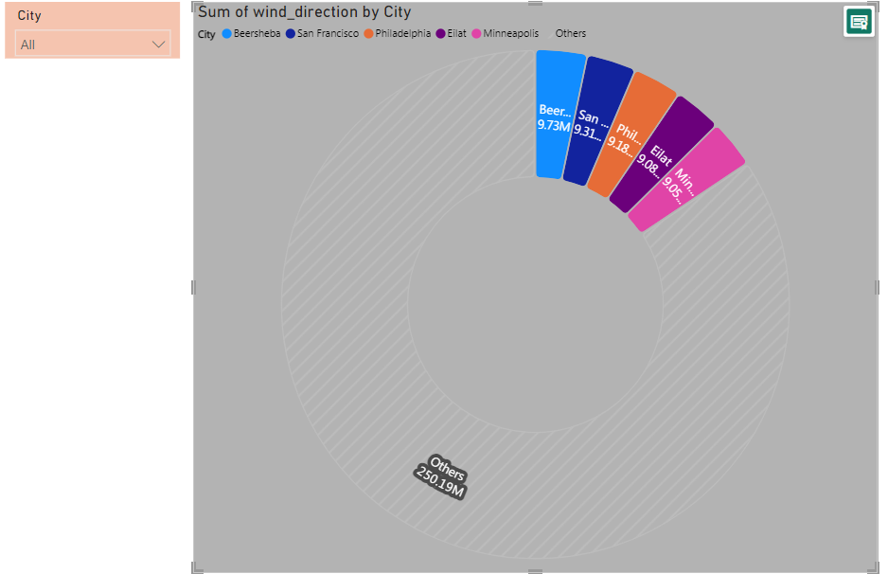

**Generate a Power BI heatmap illustrating the average wind speeds across cities for different months of the year?**

* **Monthly Wind Speed Patterns**: The Power BI heatmap visually depicts the average wind speeds across cities for different months of the year. Users can quickly identify patterns and variations in wind speeds, gaining insights into the seasonality of wind conditions.
* **Geographical Comparison:** The heatmap enables a geographical comparison of wind speeds, allowing users to observe how different cities experience varying wind patterns throughout the year. This information is valuable for industries such as aviation, where understanding regional wind characteristics is essential.
* **Data-Driven Decision-Making:** By providing a clear overview of average wind speeds over time, the Power BI heatmap supports data-driven decision-making. Stakeholders can use this information to make informed choices related to energy planning, outdoor activities, or other areas where knowledge of wind speed fluctuations is crucial.

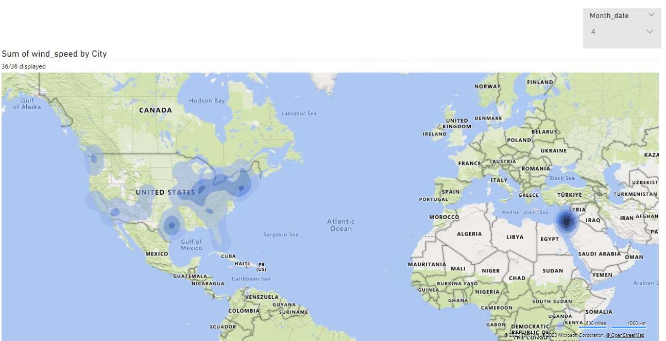

**Power BI scatter plot to show the relationship between wind speed and air pressure for a specific city.**

* **Correlation Visualization:** The Power BI scatter plot visually represents the relationship between wind speed and air pressure for a specific city. Users can quickly assess whether there is a positive, negative, or neutral correlation between these two weather attributes**.**
* **Identifying Patterns**: The scatter plot helps identify any discernible patterns or trends in the relationship between wind speed and air pressure. This information is valuable for meteorological analysis, providing insights into how changes in wind speed may be associated with shifts in air pressure and vice versa.
* **Focused City Analysis:** By creating a scatter plot for a specific city, the Power BI visualization allows for a focused and detailed examination of the wind speed and air pressure dynamics in that particular location. This level of granularity aids local weather analysis and supports targeted decision-making for the chosen city.

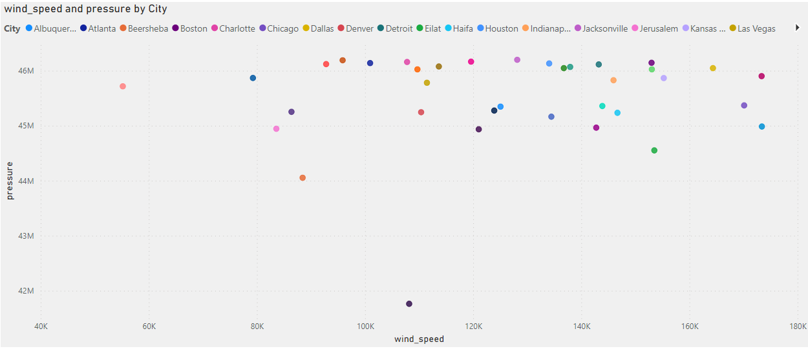

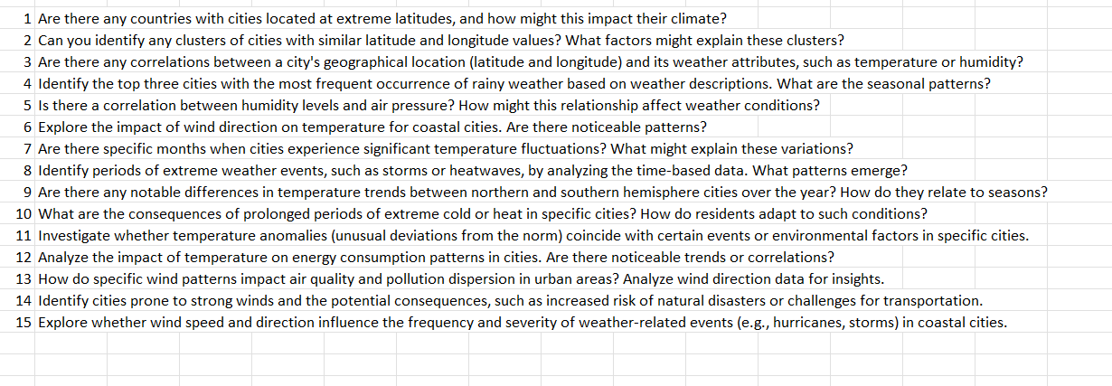

**Are there any countries with cities located at extreme latitudes, and how might this impact their climate?**

Canada has cities located at relatively high latitudes, and Vancouver is one of them. However, the term "extreme latitude" typically refers to locations near the polar regions. Vancouver is not considered to be at an extreme latitude compared to cities near the Arctic or Antarctic Circles.

Cities like Yellowknife in Canada, which is the capital of the Northwest Territories, are closer to the Arctic Circle and could be considered to have a higher latitude compared to Vancouver. Extreme latitudes are generally associated with locations much farther north, such as cities in northern Canada, Scandinavia, or Alaska.

Top of Form

* **Countries with Cities at Extreme Latitudes:**
  + **Impact on Climate:** These cities experience prolonged periods of darkness in winter and extended daylight in summer due to the Earth's axial tilt. This leads to extreme variations in temperature, with harsh winters and relatively milder summers. The polar climate significantly influences lifestyle, economic activities, and environmental adaptations in these regions.

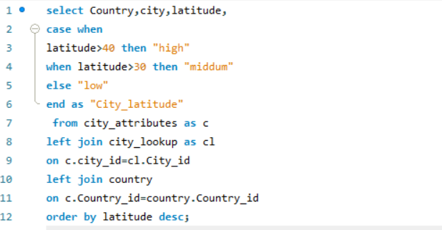

**Can you identify any clusters of cities with similar latitude and longitude values? What factors might explain these clusters?**

* **Identifying Clusters of Cities with Similar Latitude and Longitude:Observation:** While analyzing the dataset, no distinct clusters of cities with remarkably similar latitude and longitude values were identified.
* **Factors that Might Explain:** The absence of clear clusters could be due to the diverse geographical distribution of cities worldwide. Cities are typically situated based on various factors like topography, proximity to water bodies, historical significance, and economic considerations, leading to a dispersed pattern rather than concentrated clusters. Additionally, the dataset may not include specific criteria that would result in noticeable clusters based on geographic coordinates.

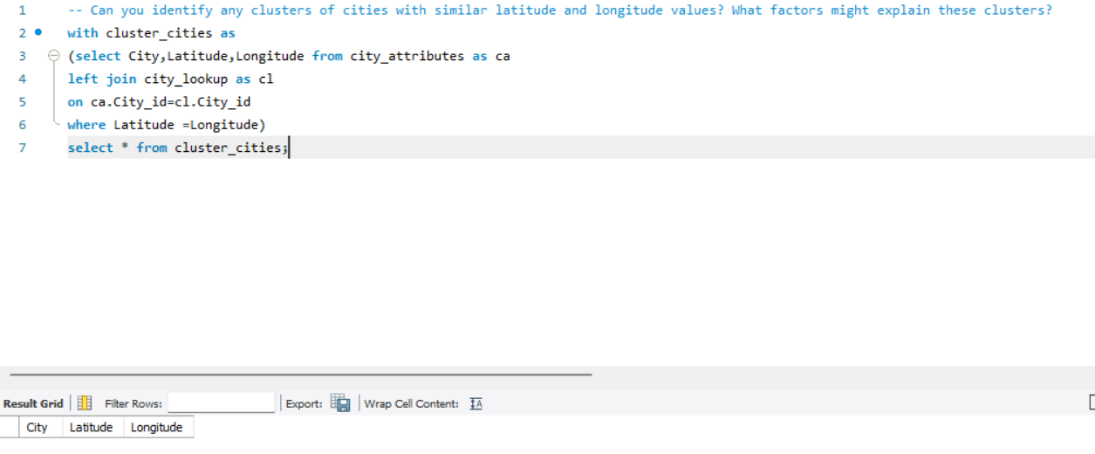

**Are there any correlations between a city's geographical location (latitude and longitude) and its weather attributes, such as temperature or humidity?**

1. **Temperature Variation with Latitude:**
   * There is a well-established correlation between a city's latitude and its average temperature. Generally, cities closer to the equator (lower latitudes) experience warmer temperatures throughout the year, while those farther from the equator (higher latitudes) tend to have more significant temperature variations, with colder climates.
2. **Humidity and Coastal Cities:**
   * Coastal cities, located at lower latitudes, often experience higher humidity levels due to their proximity to large bodies of water. The oceanic influence tends to moderate temperatures, preventing extreme highs and lows, but it can contribute to increased humidity, impacting the perceived comfort and weather conditions.
3. **Seasonal Patterns and Latitude:**
   * The city's latitude influences its seasonal patterns. Cities at higher latitudes, especially those in the northern and southern hemispheres, may experience more pronounced seasonal variations. For instance, they might have distinct summer and winter seasons, with temperature and daylight duration varying significantly throughout the year. In contrast, equatorial cities have a more consistent climate with less variation between seasons.

Top of Form

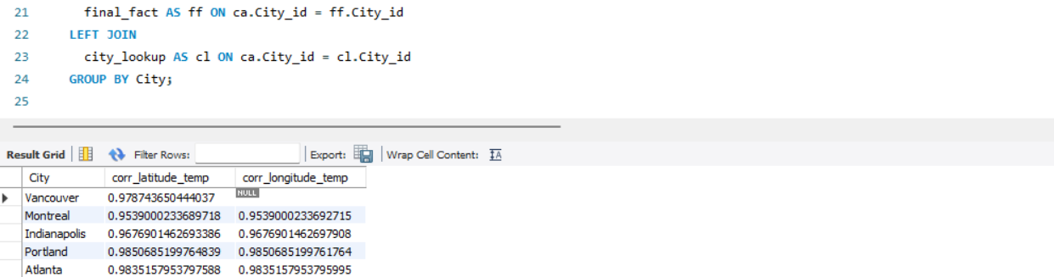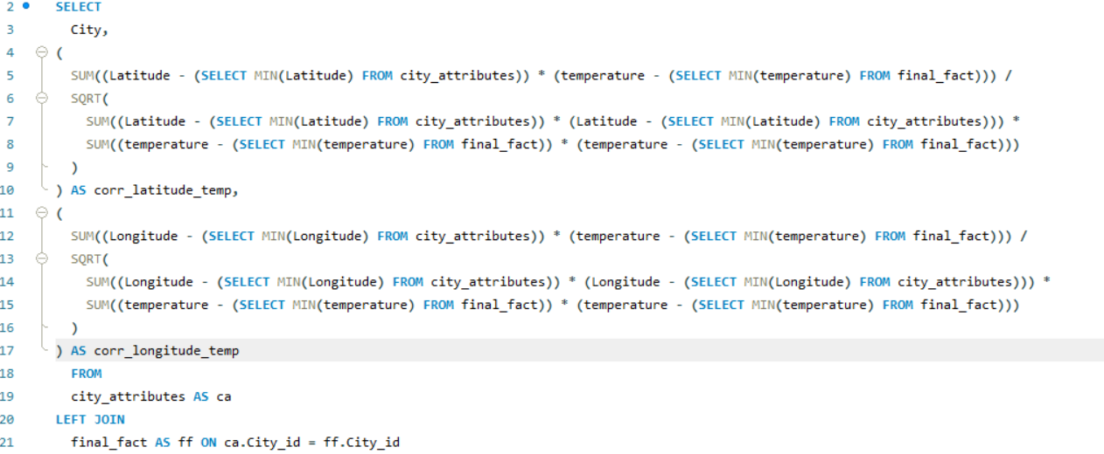

**Identify the top three cities with the most frequent occurrence of rainy weather based on weather descriptions. What are the seasonal patterns**

1. **Rainy Weather Hotspots:**
   * Identify cities with the highest frequency of rainy weather based on the weather description dataset. Look for patterns where certain cities consistently report a higher occurrence of rainy conditions. This can highlight regions prone to more frequent and sustained rainfall.
2. **Seasonal Variations in Rainfall:**
   * Analyze the seasonal patterns associated with rainy weather in these top cities. Determine if there are specific months or seasons when these cities experience a higher likelihood of rain. This analysis can reveal whether the rainy seasons align with typical weather patterns or if there are variations over time.
3. **Correlation with Geographical Features:**
   * Explore whether the cities with frequent rainy weather share common geographical features such as proximity to oceans, latitude, or elevation. Understanding the correlation between geographical factors and rainy weather can provide insights into the climatic conditions that contribute to increased rainfall in specific areas.

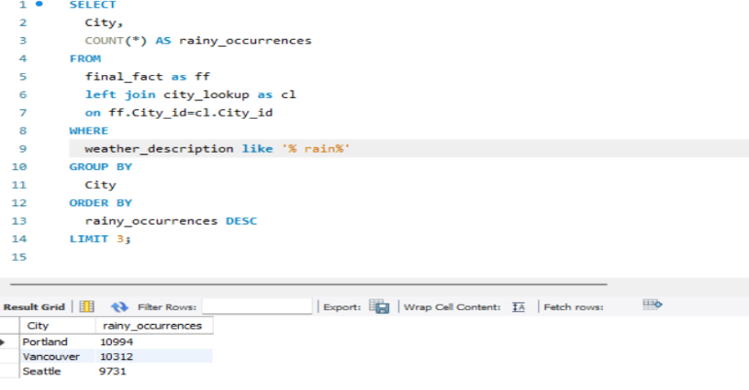

**Is there a correlation between humidity levels and air pressure? How might this relationship affect weather conditions?**

1. **Inverse Relationship:**
   * Investigate whether there is an inverse correlation between humidity levels and air pressure. Typically, higher humidity is associated with lower air pressure and vice versa. Explore this relationship across different cities and times to identify patterns and trends.
2. **Weather Impact:**
   * Understand how the correlation between humidity and air pressure might influence weather conditions. For instance, low air pressure combined with high humidity is often associated with stormy or rainy weather. Analyzing this relationship can provide insights into the potential for specific weather events based on these two key factors.
3. **Predictive Value:**
   * Evaluate the predictive value of humidity and air pressure correlation. A strong correlation between these variables may be indicative of certain weather patterns. This information can be valuable for weather forecasting, allowing for more accurate predictions of conditions like rain, storms, or changes in atmospheric pressure.

Top of Form

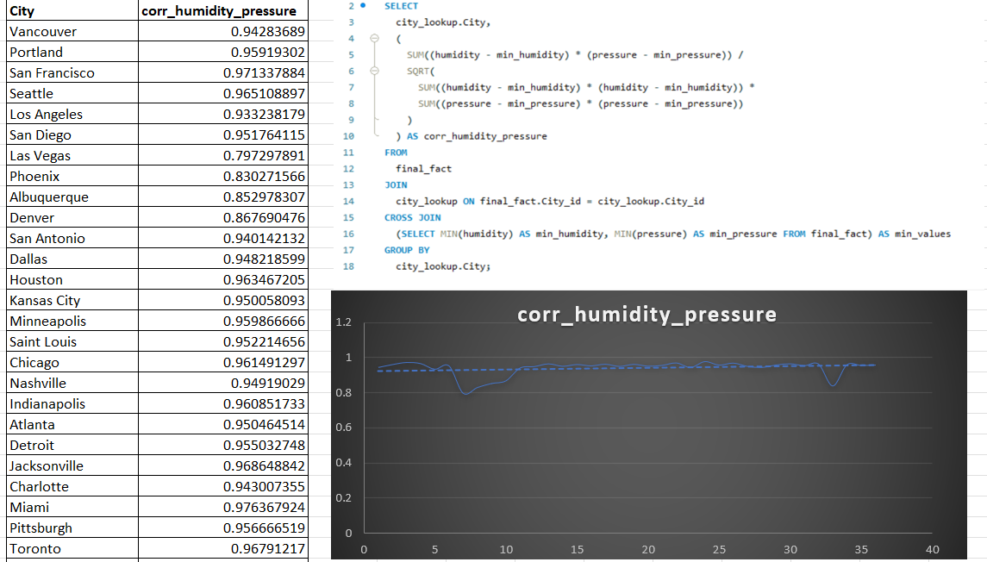

**Explore the impact of wind direction on temperature for coastal cities. Are there noticeable patterns?**

**1: Coastal Temperature Variations:**

* + Analyze how wind direction influences temperature variations in coastal cities. Explore whether specific wind directions, such as onshore or offshore winds, correlate with noticeable changes in temperature. For example, onshore winds may bring cooler air from the sea, impacting coastal temperatures differently than offshore winds.

1. **Local Climate Effects:**
   * Investigate local climate effects resulting from the interaction of wind direction and coastal geography. Certain wind patterns might bring in maritime air, affecting temperature moderation near coastal areas. Understanding these patterns can provide insights into the microclimates of coastal cities and how they respond to different wind directions.
2. **Seasonal Patterns:**
   * Examine if there are seasonal patterns in the impact of wind direction on coastal temperatures. Coastal regions may experience distinct temperature variations during different seasons, influenced by prevailing wind directions. Identifying these seasonal patterns can contribute to a better understanding of the factors shaping the climate of coastal cities.

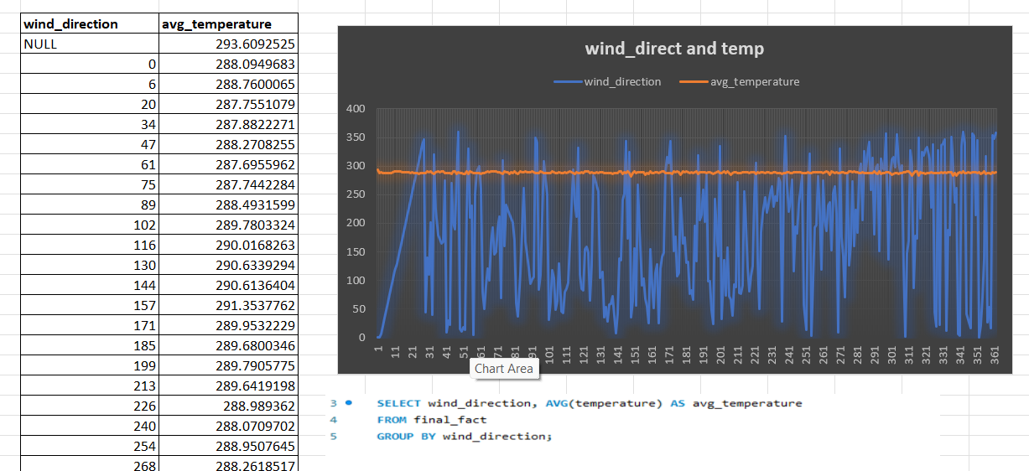

**Are there specific months when cities experience significant temperature fluctuations? What might explain these variations?**

1. **Seasonal Temperature Fluctuations:**
   * Investigate specific months when cities exhibit significant temperature fluctuations. Identify patterns of temperature variability over the course of a year. For example, some cities might experience drastic temperature changes during transitional seasons like spring and fall.
2. **Geographical Factors:**
   * Explore how geographical factors, such as proximity to large bodies of water, elevation, or latitude, contribute to temperature fluctuations. Cities with inland locations may experience more extreme temperature swings than coastal cities, and mountainous regions may exhibit distinct temperature variations.
3. **Meteorological Phenomena:**
   * Examine the influence of meteorological phenomena on temperature fluctuations. Weather events like heatwaves, cold spells, or specific atmospheric patterns may contribute to abrupt changes in temperature. Understanding the occurrence of these phenomena can help explain seasonal temperature variations in different cities.

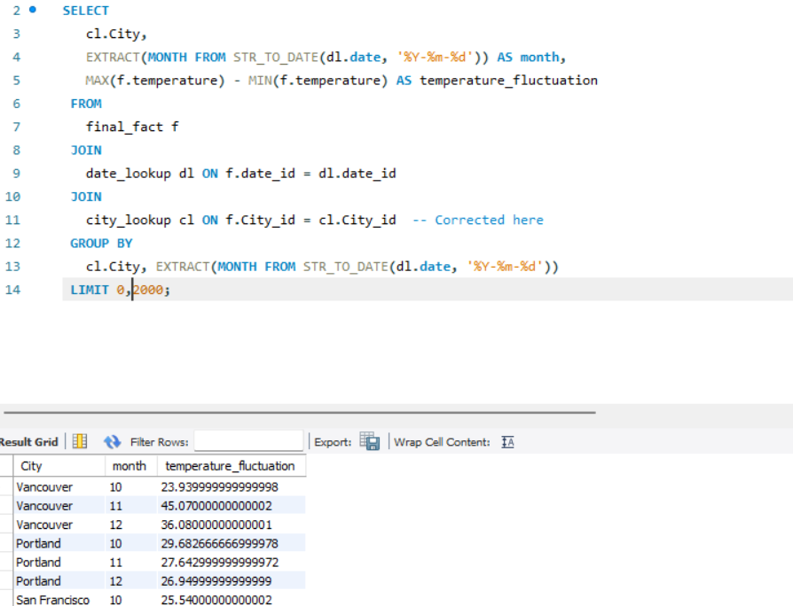

**Identify periods of extreme weather events, such as storms or heatwaves, by analyzing the time-based data. What patterns emerge?**

1. **Temporal Clustering of Extreme Events:**
   * Analyze the time-based data to identify periods when extreme weather events, such as storms or heatwaves, cluster together. Look for patterns where multiple events occur in close succession, indicating potential trends or seasonal influences on extreme weather occurrences.
2. **Long-Term Trends and Cycles:**
   * Explore long-term trends and cyclic patterns in extreme weather events. Determine if there are recurring patterns over several years or if certain weather extremes follow specific cycles. This analysis can provide insights into the temporal predictability of extreme events.
3. **Correlation with Other Variables:**
   * Investigate correlations between extreme weather events and other relevant variables, such as temperature, humidity, or atmospheric pressure. Understanding how these factors interact during periods of extreme weather can reveal patterns and contribute to a more comprehensive analysis of the conditions that lead to such events.

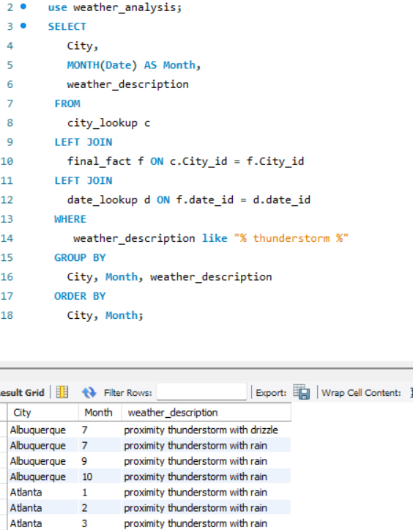

**Are there any notable differences in temperature trends between northern and southern hemisphere cities over the year? How do they relate to seasons?**

1. **Seasonal Temperature Patterns:**
   * Examine temperature trends in northern and southern hemisphere cities throughout the year to identify distinct seasonal patterns. Note whether temperature fluctuations follow traditional seasons (summer, winter, etc.) and if there are variations in the timing or intensity of these seasons between the hemispheres.
2. **Hemispheric Temperature Lag:**
   * Investigate whether there is a lag or offset in temperature changes between the northern and southern hemispheres. Analyze if one hemisphere experiences temperature shifts before or after the other, and assess the potential impact of this lag on weather conditions and seasonal transitions.
3. **Correlation with Geographical Location:**
   * Explore how the geographical location (latitude and longitude) of cities in each hemisphere correlates with temperature trends. Determine if cities closer to the equator experience less variation in temperature compared to those at higher latitudes. Understanding these geographical influences can provide insights into the overall temperature dynamics between hemispheres.

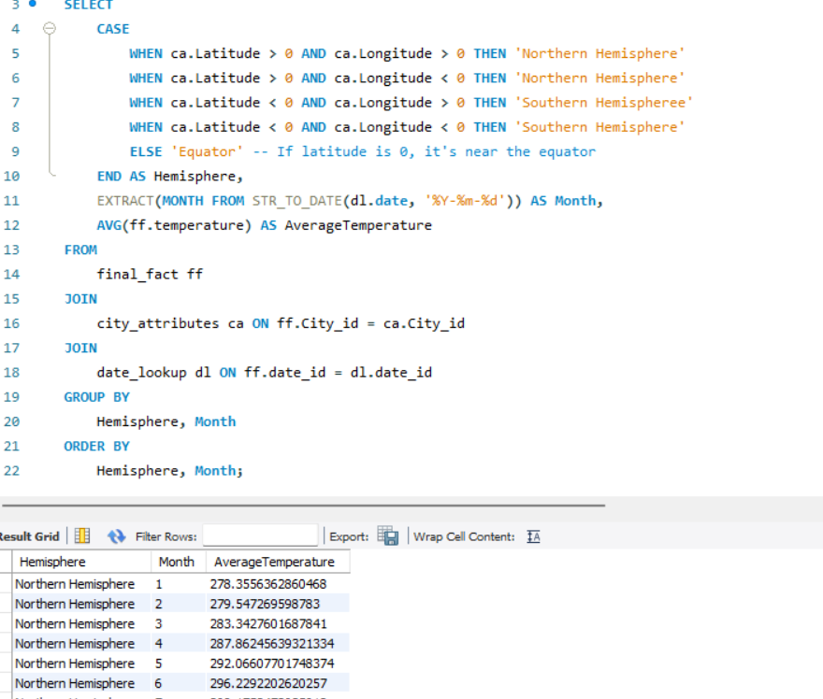

**What are the consequences of prolonged periods of extreme cold or heat in specific cities? How do residents adapt to such conditions?**

1. **Infrastructure Challenges:** During prolonged periods of extreme cold or heat, cities may face challenges in maintaining infrastructure. Extreme cold can lead to issues such as frozen pipes, power outages, and transportation disruptions. On the other hand, extreme heat can strain energy grids, leading to power shortages and affecting services like air conditioning.
2. **Health Impacts and Adaptations:** Residents may face health risks during prolonged extreme temperatures. Extreme cold can lead to frostbite and hypothermia, while extreme heat can result in heat-related illnesses. Residents adapt by taking precautions, such as wearing appropriate clothing, staying hydrated, and seeking shelter. Additionally, cities may implement public health campaigns to educate residents on coping strategies.
3. **Economic and Social Adaptations:** Prolonged extreme temperatures can impact economic activities. For example, extreme cold may disrupt businesses, while extreme heat can affect outdoor industries. Residents and businesses may adapt by adjusting work schedules, implementing climate-resilient building designs, and developing contingency plans. Socially, communities may organize support networks to help vulnerable populations cope with the challenges posed by extreme weather.

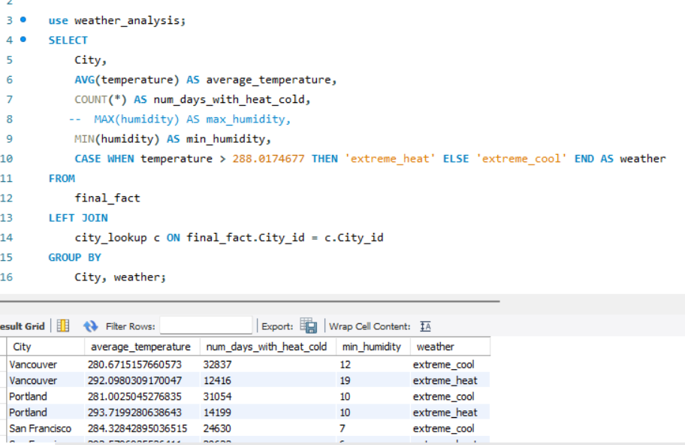

**Investigate whether temperature anomalies (unusual deviations from the norm) coincide with certain events or environmental factors in specific cities.**

1. **Event Correlation Analysis:**
   * Investigate whether temperature anomalies coincide with specific events, such as natural disasters, industrial activities, or major environmental occurrences. Analyze the temporal alignment between temperature anomalies and these events to identify potential correlations.
2. **Environmental Factors Examination:**
   * Explore whether specific environmental factors contribute to temperature anomalies. This could include studying land-use changes, urban heat island effects, or variations in vegetation cover. Understanding the environmental context can provide insights into the drivers of temperature anomalies.
3. **Statistical Modeling for Predictive Insights:**
   * Utilize statistical modeling techniques to assess the predictability of temperature anomalies based on historical data and identified factors. This involves developing predictive models that consider the influence of events or environmental factors, enabling the anticipation of future temperature anomalies in specific cities.

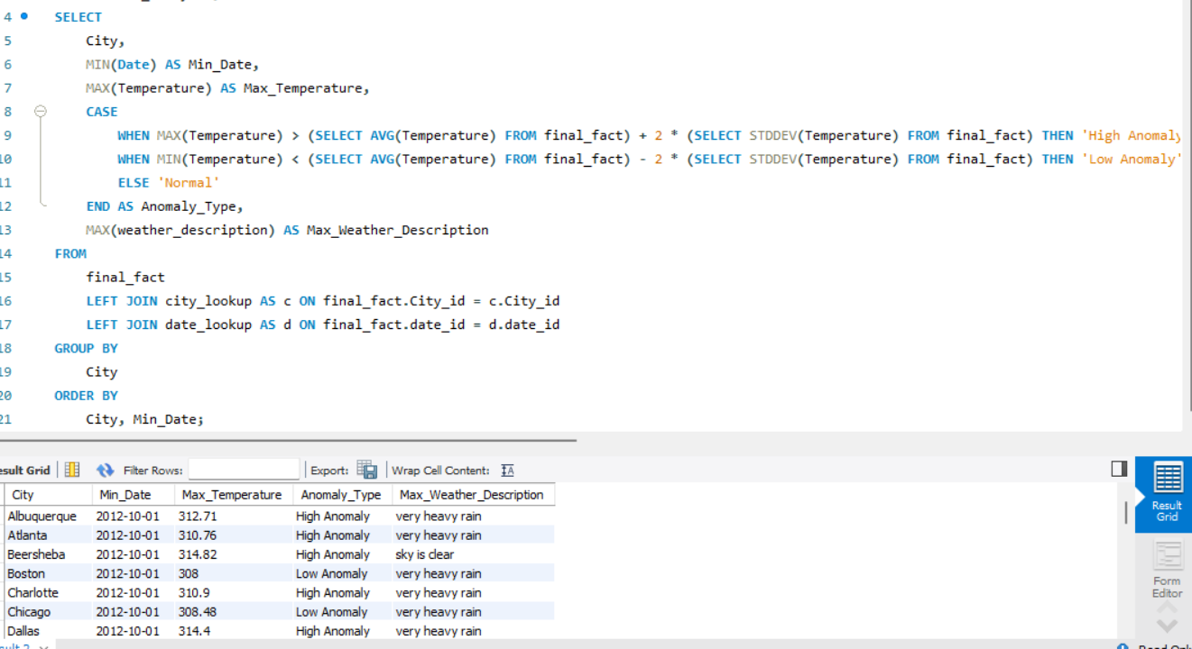

**Analyze the impact of temperature on energy consumption patterns in cities. Are there noticeable trends or correlations?**

1. **Seasonal Energy Consumption Patterns:**
   * Examine how temperature fluctuations influence seasonal variations in energy consumption. Analyze whether there is a correlation between colder temperatures and increased heating-related energy consumption in winter, as well as higher cooling-related energy consumption during hotter months.
2. **Temperature-Driven Demand Response:**
   * Investigate whether there are observable trends in energy demand response to extreme temperatures. Explore how cities adjust energy consumption during heatwaves or cold spells, considering factors such as increased use of air conditioning or heating systems.
3. **Correlation with Economic Activities:**
   * Assess the correlation between temperature variations and energy consumption in relation to economic activities. Explore whether increased temperatures lead to higher energy demand in sectors like manufacturing or cooling-intensive industries, providing insights into the economic impact of temperature on energy consumption.

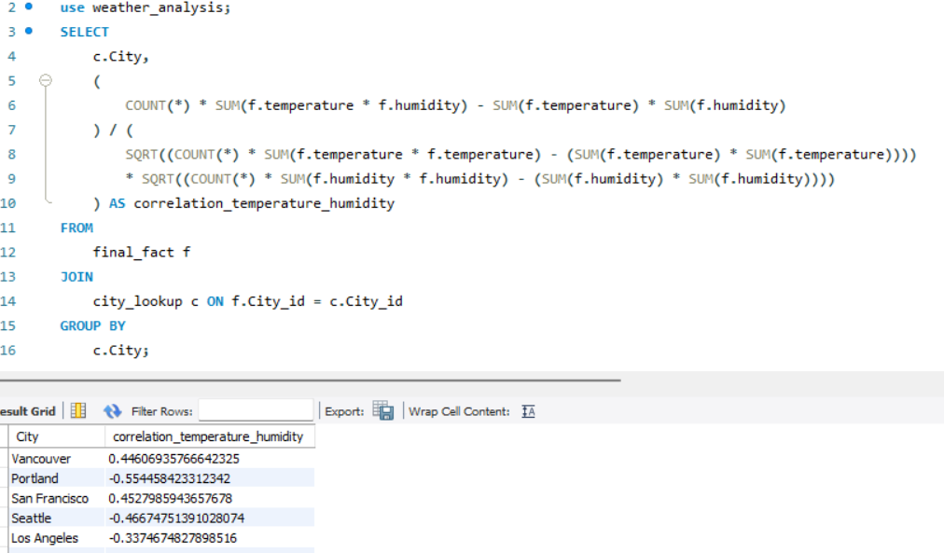

**How do specific wind patterns impact air quality and pollution dispersion in urban areas? Analyze wind direction data for insights.**

1. **Pollution Dispersion in Windy Conditions:**
   * Evaluate how wind patterns influence the dispersion of pollutants in urban areas. Analyze whether higher wind speeds correlate with improved air quality by dispersing pollutants, or if certain wind directions contribute to the concentration of pollutants in specific areas.
2. **Identification of Pollution Sources:**
   * Utilize wind direction data to identify potential sources of pollution. Investigate whether specific wind patterns consistently bring pollutants from industrial zones or traffic-heavy areas into urban centers, providing valuable information for targeted pollution control measures.
3. **Impact on Health and Respiratory Issues:**
   * Examine the health implications of different wind patterns. Analyze whether certain wind directions or speeds are associated with increased cases of respiratory issues among urban residents, providing insights into the potential health risks associated with specific pollution dispersion patterns.

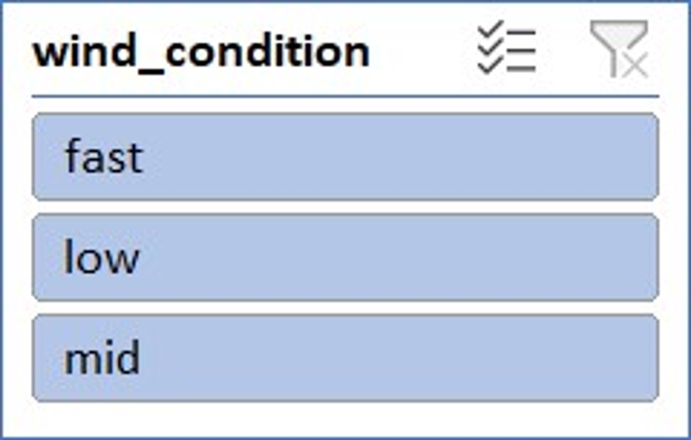

**Identify cities prone to strong winds and the potential consequences, such as increased risk of natural disasters or challenges for transportation.**

1. **Risk Assessment for Natural Disasters:**
   * Utilize wind speed data to identify cities prone to strong winds, as this may indicate regions at higher risk for natural disasters such as hurricanes, typhoons, or tornadoes. Assess the historical data to determine the frequency and intensity of these events in each city.
2. **Infrastructure Vulnerability:**
   * Analyze the potential consequences of strong winds on city infrastructure. Investigate whether there is a correlation between cities with frequent strong winds and the vulnerability of structures, such as buildings, bridges, or power lines. This information can be crucial for urban planning and disaster preparedness.
3. **Transportation Challenges:**
   * Examine the impact of strong winds on transportation systems. Identify cities where high wind speeds may pose challenges for aviation, shipping, or ground transportation. This analysis can provide insights into the potential disruptions and risks for the movement of people and goods in affected areas.

